Virtual Lab 2 – Microstrip Transmission Lines

Pre-Laboratory:

Read the textbook regarding the microstrip line. Which parameter affects the characteristic impedance? How do you adjust these parameters to achieve 50-ohm characteristic impedance?

Read the textbook to understand propagating wave, standing wave, VSWR, guided wavelength.

Simulation Procedure:

Part 1 Microstrip Transmission Line Propagation

- Create a microstrip line on a Teflon substrate inside an air box. This structure consists of four boxes. To build the structure, first create a large box with dimensions 5×3×1 cm³. Set the material in this box to be vacuum or air. The Teflon substrate is 2 mm thick and the ground plane (PEC) under the Teflon substrate is 0.5 mm thick. The microstrip line on the Teflon substrate is also 0.5 mm thick. The width of the microstrip line is 5 mm. Your structure should resemble those found in Figure 1 and Figure 2. The bottom of the ground plane should sit on the bottom of the air box.

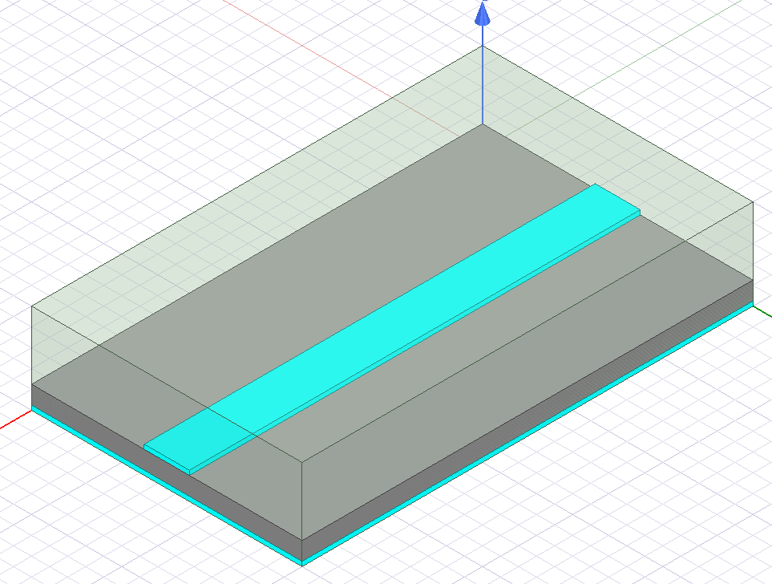
Figure 1 Microstrip line on Teflon substrate inside an air box
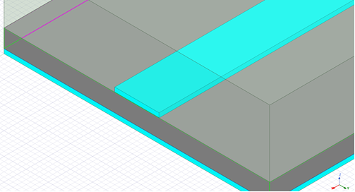
Perfect conductor microstrip

ground plane
Teflon substrate
Vacuum Region
Figure 2 Close-up of microstrip geometry illustrating material composition

- Define the ports as follows: Select one sidewall of the air box (which is perpendicular to the microstrip line) as shown below and assign Port 1. Port 2 is the opposite side of the air box.
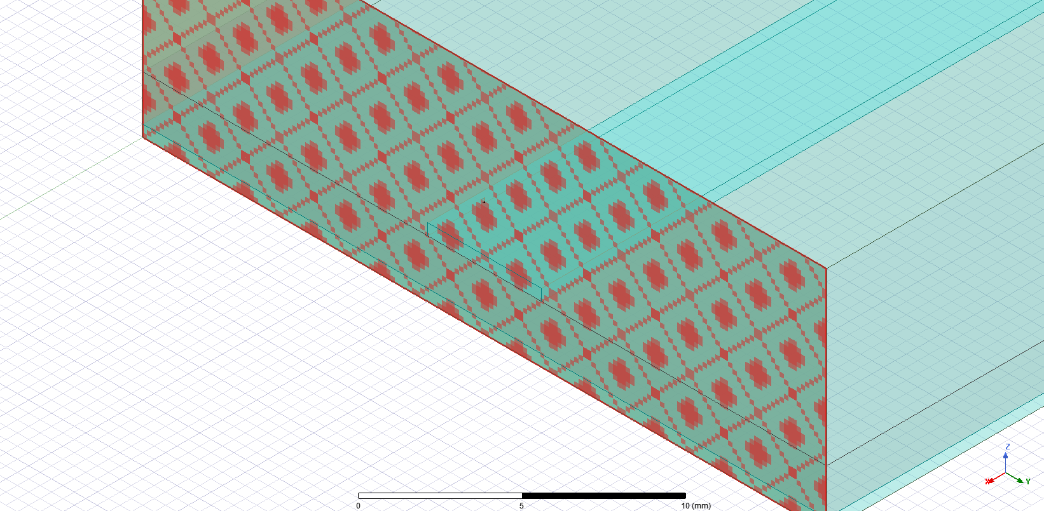

- Assign the two side walls which are in parallel with the microstrip line as perfect H boundary (natural boundary).
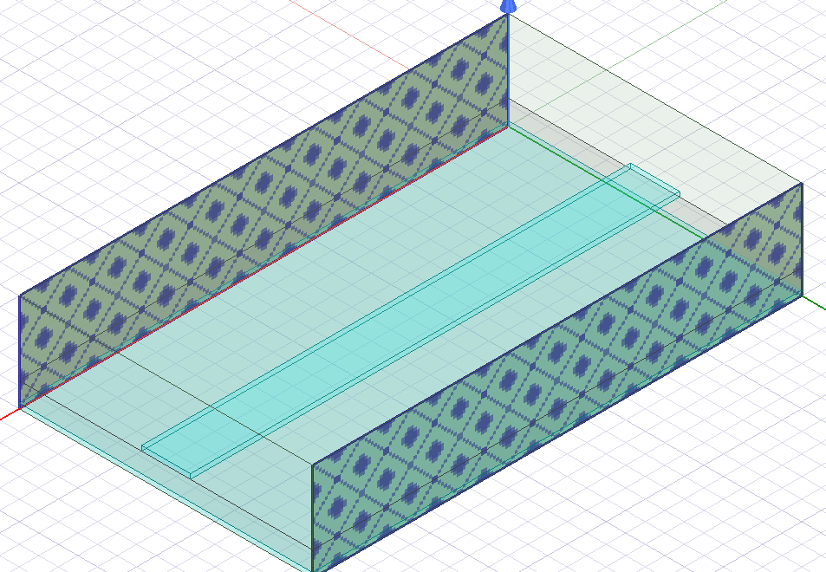

- Set the solution frequency of 12 GHz and run a frequency sweep from 1–12 GHz. Choose an appropriate number of adaptive passes to achieve a Max delta S of less than 0.02. Note that this simulation will need to run through about 6-7 adaptive passes and may take up to about 10 minutes depending on the computer you are using.

Part 2 Open-ended Microstrip Line

- Create a new project and draw a microstrip line as in part 1, however this time it is only 3 cm long. Everything else is the same. This structure represents an open-ended microstrip line as seen in Figure 3. To save time, you may copy the project in part 1 and simply adjust the length of the microstrip line.
- Define the materials and boundaries in the same way as in part 1. However, the sidewall corresponding to Port 2 in part 1 should be defined as a perfect H (natural) boundary.
- Set the solution frequency of 12 GHz. Choose an appropriate number of adaptive passes to achieve a Max delta S of less than 0.02.
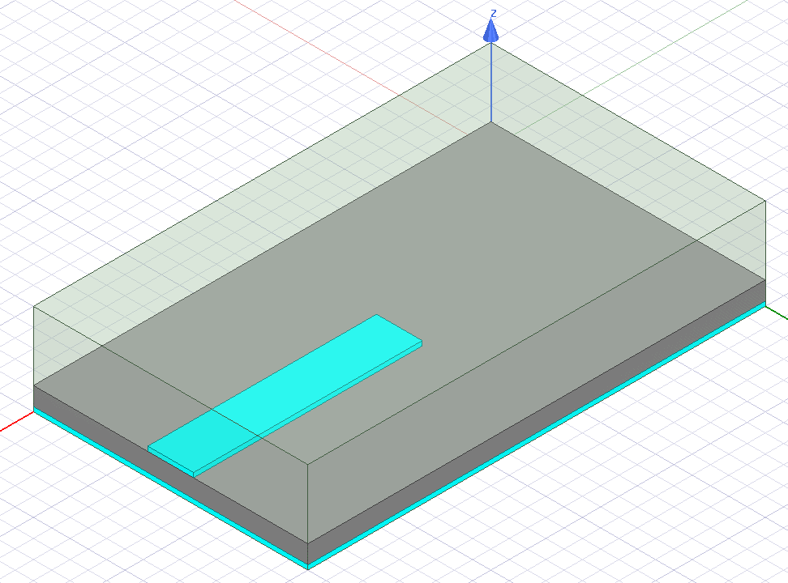
Figure 3 Model for Open-ended Microstrip Line

Part 3 Short Circuit on a Microstrip Transmission Line

- Copy the open-ended microstrip project into a new project and add a metallic via as shown in the figure below. Draw a cylinder with a radius of 1 mm and a height of 2 mm at the end of the microstrip line. Assign the cylinder as PEC. The cylinder represents a metallic via connecting the microstrip and ground plane, shown in Figure 4. The cylinder should be completely inside the Teflon substrate. The top and bottom of the cylinder are in contact with the microstrip line and the ground plane, respectively. The edge of the cylinder should align with the open end of the microstrip line.
- The materials and boundaries should be the same as in part 2.
- Set the solution frequency of 12 GHz. Choose an appropriate number of adaptive passes to achieve a Max delta S of less than 0.02
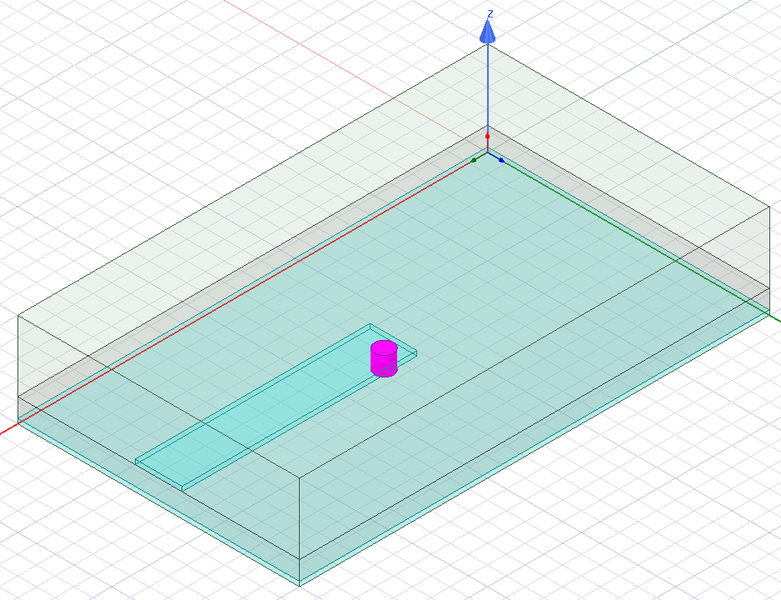
Figure 4 Model for Short-Ended Microstrip Line

Lab Reports

Results for Part 1
- (10 pts) Calculate the effective dielectric constant and characteristic impedance of this microstrip line using the formulas in Pozar’s book. Compare your calculation results with the results from HFSS. (Hint: the effective dielectric constant is somewhat hidden. See the following screen capture and find it.)

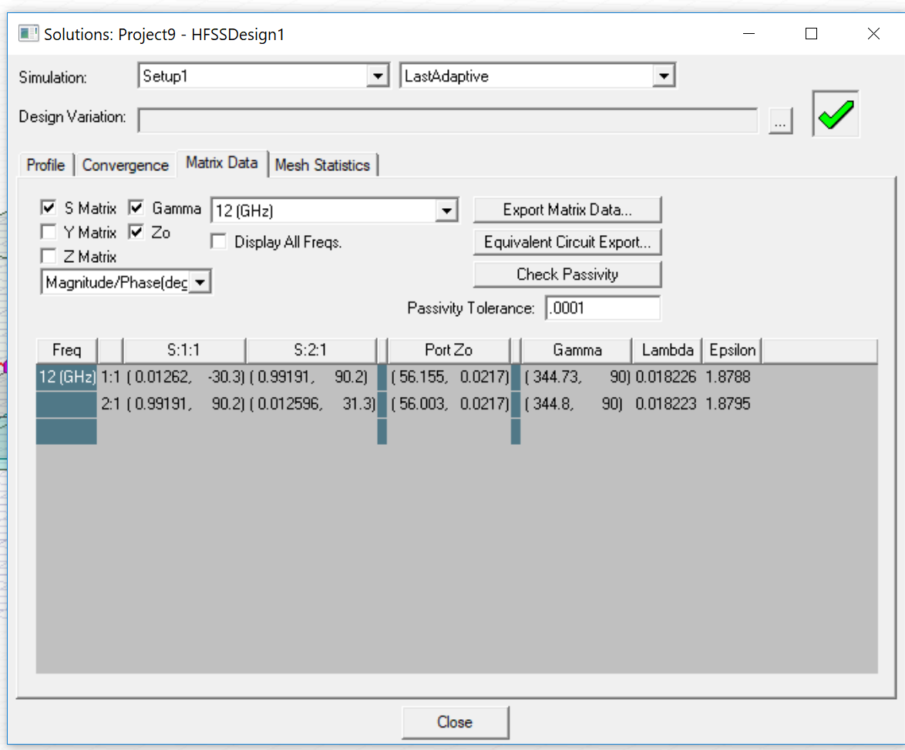

- (15 pts) Generate E and H field plots at the ground-substrate interface and also at the substrate-microstrip interface. Accomplish this by plotting the magnitude of the field on the surface of the appropriate box (Mag_E and Mag_H). For each interface, include two screen captures; one for the magnitude of the electric field and another for the magnetic field, each for zero phase.

- (5 pts) Plot all four S parameters from 1-12 GHz.

- (10 pts) Why are the fields at the two planes different? Hint: In light of the previous question, consider the static field distribution. Make a static field plot of the microstrip cross section if it helps you visualize what is happening.

Results for Part 2: Open Circuit

- (20 pts) For the open-ended microstrip line, include four screen captures at the ground-substrate interface; include one for the magnitude of the electric field and another for the magnetic field, for phases of 0 and 90 degrees. Set the maximum E field strength in the plot to be 10000 (V/m). Set the maximum H field strength in the plot to be 40(A/m). Describe key features for the electric field at the open end of the microstrip line.

- (10 pts) Is the field pattern a standing wave or a traveling wave, and what is the spatial period of the field distribution (This is also referred to as the guided wavelength)?

Results for Part 3: Short Circuit

- (20 pts) For the short-circuited microstrip line, include four screen captures at the substrate-microstrip interface; one for the magnitude of the electric field and another for the magnetic field, for phases of 37 and 127 degrees. Set the maximum E field strength in the plot to be 10000 (V/m). Set the maximum H field strength in the plot to be 40(A/m). Describe key features for the magnetic field around the cylinder.

- (10 pts) Is the field pattern a standing wave or a traveling wave, and what is spatial period of the field distribution (This is also referred to as the guided wavelength)?

